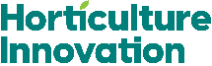
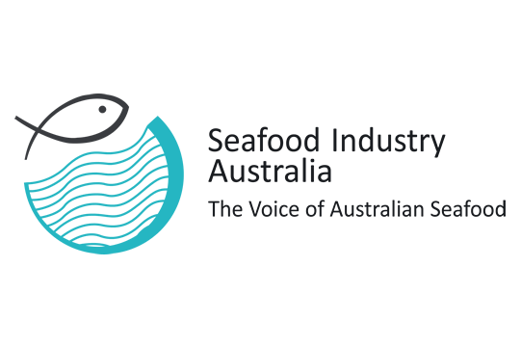

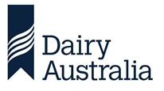
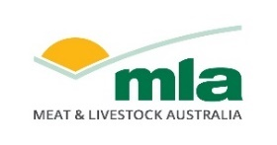
Media release
21 December 2025
Taste the Wonders of Australia returns to South Korea to strengthen trade partnership
The Australian Food and Wine Collaboration Group will make its first return visit early next year when it heads to South Korea for its eighth Taste the Wonders of Australia campaign.
The Collaboration Group, which includes Hort Innovation, Dairy Australia, Wine Australia, Meat and Livestock Australia and Seafood Industry Australia, aims to deepen commercial relationships with key partners in trade, retail and foodservice, reinforcing South Korea as a priority export destination for Australia’s premium food and beverages.
South Korea is one of Australia’s most significant trade partners, with a population of more than 50 million and dense urban centres.
Two-way trade has nearly doubled since the Korea-Australia Free Trade Agreement (KAFTA) commenced in 2014, rising from $33 billion in 2013 to $71 billion in 2023. For agriculture, South Korea is Australia’s third largest market for exports, worth an estimated $4.2 billion in 2024-25.
Dairy Australia Sustainable International Trade Senior Manager Catherine Taylor said South Korea is a fast-moving market with increasing demand for high-quality food and beverage imports.
“South Korea is a key market for Australian agribusiness exports,” Ms Taylor said. “Our regional proximity, decade-long trade partnership and the maturity of KAFTA make returning to Seoul a natural next step.
“This visit is about consolidating momentum and deepening the relationships that underpin long-term export success. Provenance, food safety and quality are highly valued in South Korea, and trust in Australian products is strong across beef, dairy, wine, seafood, fruit, vegetables and nuts.”
Ms Taylor said South Korea’s appetite for innovation makes it a valuable market for new products and ingredients.
“Cafe culture and product innovation are remarkable in Korea – it sets the trend in the region. Australian ingredients are also used in Korean-made goods exported across Asia, extending the reach of our agriculture even further,” she said.
The market activation in Seoul on February 25 and 26 will feature market roundtables with industry and government representatives, food and wine workshops presented by renowned Korean chefs and educators, a media conference, and a Taste the Wonders of Australia Gala Dinner showcasing premium Australian produce to Korean industry representatives. It’s a format that has proven extremely successful for the group working together as Team Australia under the Nation Brand.
Wine Australia General Manager Market Development Paul Turale said South Korea represents a strong growth opportunity for Australian wine.
“In the 12 months to September 2025, 155 Australian wineries exported 4.7 million litres of wine to South Korea valued at $27.3 million,” Mr Turale said.
“With the wine segment forecast to grow steadily in South Korea over the coming years, we look forward to returning to the market to reconnect with partners and reaffirm our commitment.
“A Team Australia approach provides us with an opportunity to showcase the quality, diversity, and unique stories behind premium Australian wine, positioning it as a compelling choice for this influential audience.”
South Korea is Australia’s third largest beef export destination, valued at nearly $2.4 billion. Meat & Livestock Australia Regional Manager for Japan and Korea Travis Brown said red meat continues to underpin a strong trade relationship.
“South Korea is a cornerstone market for Australian red meat, with strong demand for premium beef, lamb and goat. Our goal is to build on this momentum and ensure Australian red meat remains the preferred choice for Korean consumers.”
Since the Collaboration Group started its market access program in 2022, it has delivered activations in Thailand, Vietnam, South Korea, Indonesia, Taiwan, Japan and Malaysia.
Over the past three years, the group has met with more than 1,450 government and trade representatives, leveraging the export capability of each sector to drives market access, expand commercial networks and supports long-term growth for Australian producers.
The investment by the Australian Food and Wine Collaboration Group is supported by Agriculture Trade and Market Access Cooperation (ATMAC) grants, with a $500,000 for the first four export market destinations in 2022-24, and a second grant of $600,000 to continue the program in 2025-26

Additional quotes:
Quotes attributable to:
Hort Innovation Australia General Manager, Trade & Biosecurity R&D Dr Mila Bristow
“South Korea represents a strategically important market for Australian horticulture. Consumers increasingly expect year-round access to premium produce, which imported product supports, particularly when Australian supply is counter-seasonal,” Dr Bristow said.
“Under KAFTA we’ve seen strong growth in horticulture exports, with table grapes, citrus, macadamias, potatoes and asparagus leading the way. Our focus is on strengthening trusted relationships with South Korean partners to support long-term collaboration.”
Quotes attributable to:
Seafood Industry Australia spokesperson
“Australia exported around $4.8 million in seafood products to South Korea in 2024–25, including coral trout, rock lobster, Atlantic salmon and other high-value species. This is a market that appreciates quality, sustainability and provenance,” Ms Papacosta said.
“The Collaboration Group is the perfect platform to introduce our top-quality seafood to Korean consumers and industry, showcasing Great Australian Seafood alongside wine, meat and horticulture for a true Australian dining experience.”

Media contact details:
For more information or to organise an interview with a representative from the Australian Food and Wine Collaboration Group, contact Natalee Ward, 0408 377 901.

